"Crossing Borders: A Successful Meeting Between Rechi - Taiwan and Tixbee - India" 13/03/2023 04:10

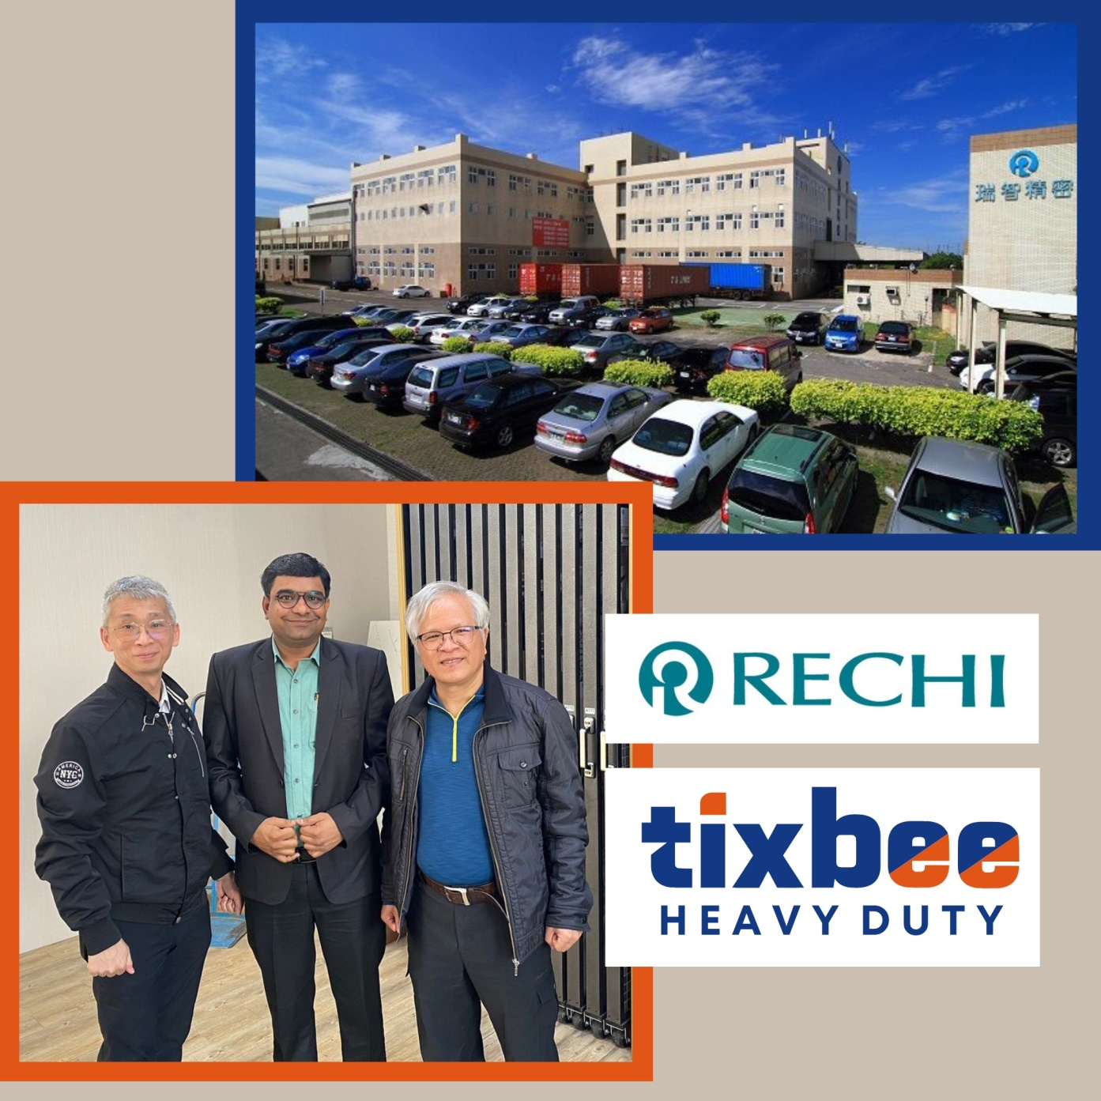

Great news! We're pleased to report that the meeting between Rechi Taiwan and Tixbee India has been successfully held. During the meeting, both companies engaged in productive discussions regarding possible cooperation for the sales of rotary compressors and BLDC motors in India's air conditioning industry. We explored various business strategies and partnership opportunities, with the aim of expanding our market presence in this important sector. It was a fantastic opportunity to learn from one another, share ideas, and explore ways to build a mutually beneficial partnership. We're excited to continue exploring potential collaboration with Tixbee India and look forward to updating you on our progress soon! #RechiTaiwan #TixbeeIndia #cooperation #partnership #airconditioning #marketexpansion

